**User Story Name: Creating an Account with Email**

* Description: **As a** User **I would like** to be able create an account with SkillCourt with an email and password combination **so that** I do not have to use the already available Facebook login option

Acceptance Criteria

* Account can be successfully created on the SkillCourt website
* Sign up form is simple to use

**Use Case**

* Name: Creating an Account with Email
* Actor: User
* Preconditions: User does not already have an account associated with their email address, and is on the sign in page
* Description <Flow of events>:

|  |  |
| --- | --- |
| Actor Steps | System Steps |
| 1. User clicks ‘create an account with e-mail’ link |  |
|  | 1. System redirects the user to the ‘standardCreateAccount’ page |
| 1. User fills out the displayed form (in full) with their information |  |
| 1. User clicks ‘Create Account’ button |  |
|  | 1. System checks if all entered information is acceptable |
|  | 1. Account is created and registered in Firebase |
|  | 7. User is logged into their new account |
|  | 8. User is redirected to the ‘Users’ page |

**Use Case Diagram**

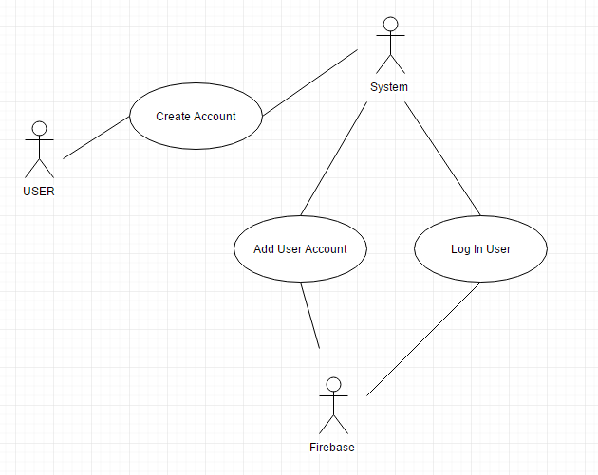

**Sequence Diagram**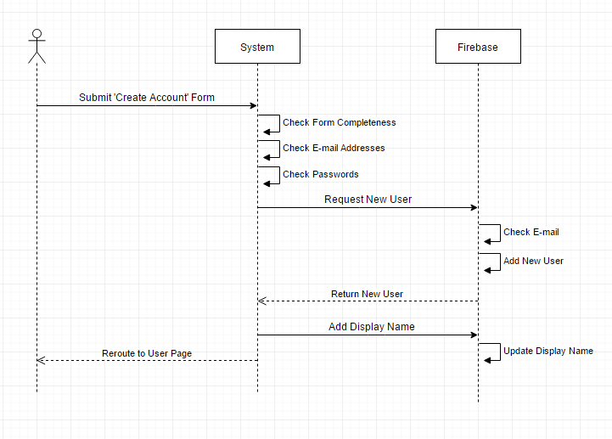

**Class Diagram**

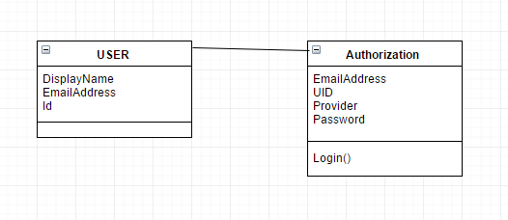

**Unit Test**

* Test case ID: Creating an Account with Email
* Description/Summary of Test: Test the ability for a user to fill out a given form and upon submission of that form, create an account with Firebase and log the user into their new account
* Pre-condition: email being used is not already registered in Firebase
* Expected Results: Successful creation of a new account
* Actual Result: Account was created successfully, and the user was logged in and redirected correctly
* Status (Fail/Pass): Pass

**Integration Test**

**Visual User Guide** <like one or two screenshots of the feature. For the hardware project, a photo of device is required>

